REQUIREMENTS:
- A Business plan
- Memorandum of Association (MoA)
- Articles of Association (AoA)
- Certificate of Incorporation
- Founders Agreement
- Shareholder Agreement
- Non-Disclosure Agreement (NDA)
- Intellectual Property (IP) assignment agreements
- Employment agreements and depending on the industry, relevant permits and licenses, along with details like director identification numbers and tax registration information.
10.Annexures
Key points about startup documentation:
- Founders Agreement:
A legal contract outlining the roles, responsibilities, ownership percentages, and exit strategies of each co-founder within the startup.
- Shareholder Agreement:
Defines the rights and obligations of shareholders, including procedures for transferring shares and decision-making.
- Non-Disclosure Agreement (NDA):
Protects confidential information shared with potential investors, partners, or clients.
- Intellectual Property (IP) Assignment Agreement:
Ensures that any intellectual property developed by employees or founders belongs to the company.
- Business Plan:
A comprehensive document outlining the company's mission, target market, marketing strategy, financial projections, and operational plans.
- Employment Agreements:
Contracts outlining the rights and responsibilities of both the employer and employee.
- Company Registration Documents:
Includes the Certificate of Incorporation, Memorandum of Association (MoA), and Articles of Association (AoA).
Important factors to consider when gathering documentation:
- Industry-Specific Regulations:
Depending on the industry, additional permits, licenses, and compliance requirements may be necessary.
- Legal Counsel:
Consulting with a lawyer is crucial to ensure all documentation is legally sound and appropriate for your business model.
- Regular Updates:
As the company evolves, key documents like the shareholder agreement or founders agreement may need to be reviewed and updated.
- Essential Legal Documents For Startup - IndiaFilings
9 Dec 2024 — The Articles of Association (AOA) is another essential document for startups. It acts as a user manual for the company,
Razorpay
FOR payment gateway purposes
DOCUMENTS REQUIRED WHEN FOR DPIIT

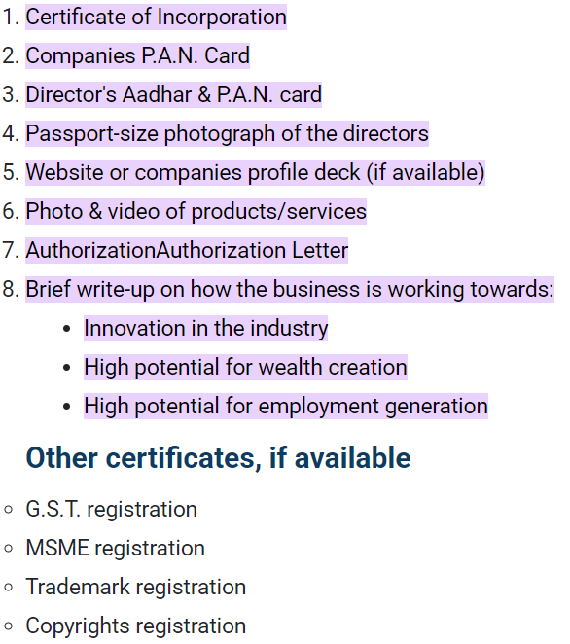
Other required documents
1.Trade mark
2.

